**Course One**

# Foundations of Data Science



# Instructions

Use this PACE strategy document to record decisions and reflections as you work through this end-of-course project. You can use this document as a guide to consider your responses and reflections at different stages of the data analytical process. Additionally, the PACE strategy documents can be used as a resource when working on future projects.

# Course Project Recap

Regardless of which track you have chosen to complete, your goals for this project are:

* Complete the PACE Strategy Document to plan your project while considering your audience members, teammates, key milestones, and overall project goal.
* Create a project proposal for the data team.

# Relevant Interview Questions

Completing this end-of-course project will empower you to respond to the following interview topics:

* As a new member of a data analytics team, what steps could you take to get 'up to speed' with a current project? What steps would you take? Who would you like to meet with?
* How would you plan an analytics project?
* What steps would you take to translate a business question to an analytical solution?
* Why is actively managing data an important part of a data analytics team's responsibilities?
* What are some considerations you might need to be mindful of when reporting results?

**Reference Guide**

This project has three tasks; the following visual identifies how the stages of PACE are incorporated across those tasks.

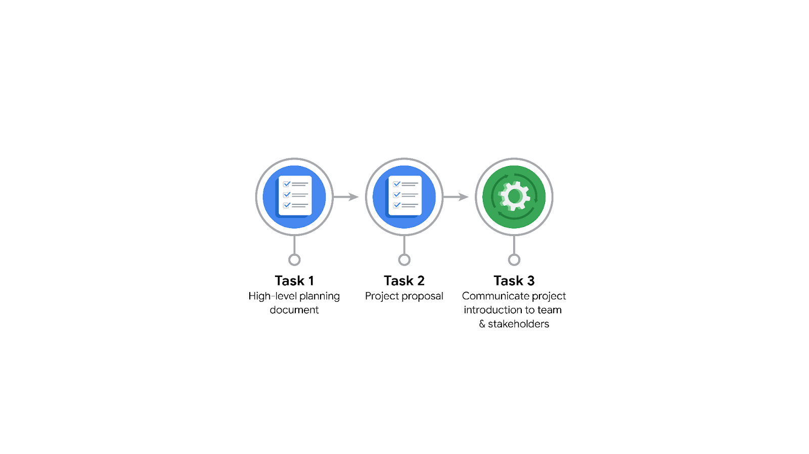

**Data Project Questions & Considerations**

**PACE: Plan Stage**

* Who is your audience for this project?

Taxi and Limousine Commission (TLC)

* What are you trying to solve or accomplish? And what do you anticipate the impact of this work will be on the larger needs of the client?

Analyse the behavior of users of Taxi’s in the city of NC

Define the best strategy of the company to find

* What questions need to be asked or answered?

Who is using the service and how and when they are using It ?

What can we do to get more users ?

* What resources are required to complete this project?

Data from the TLC for Trips in NYC

* What are the deliverables that will need to be created over the course of this project?

Project proposal

EDA

Model

results

## 

## **THE PACE WORKFLOW**

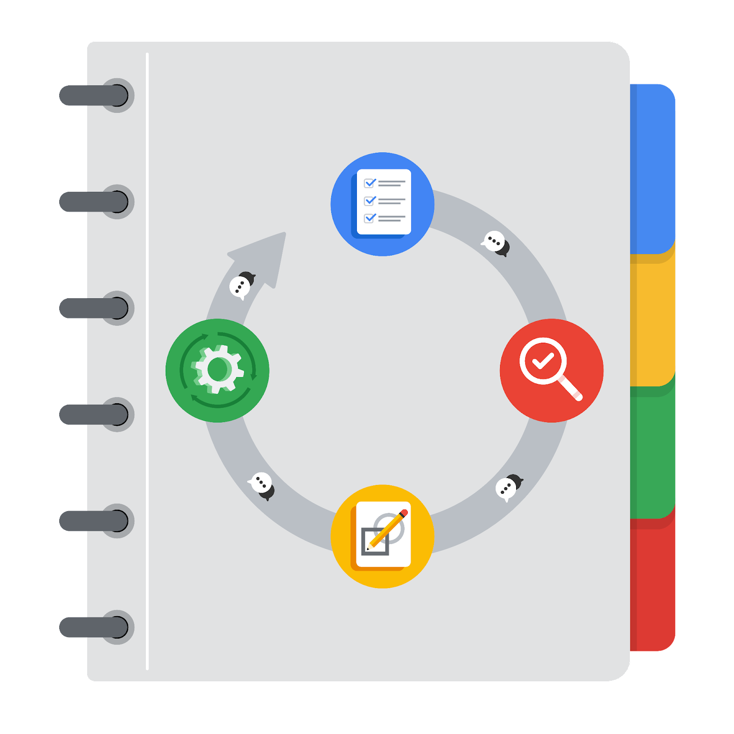

**[Alt-text: The PACE Workflow with the four stages in a circle: plan, analyze, construct, and execute.]**

You have been asked to demonstrate for the company's data team how you would use the PACE workflow to organize and classify tasks for the upcoming project. Select a PACE stage from the dropdown buttons. A few tasks involve more than one stage of the PACE workflow. Additionally, not every workplace scenario will require every task. Refer back to the Course 1 end-of-course portfolio project overview reading if you need more information about the tasks within the project.

### 

### **Project tasks**

Following are a group of tasks your company’s data team has determined need to be completed within this project. The data analysis manager has asked you to organize these tasks in preparation for the project proposal document. First, identify which stage of the PACE workflow each task would best fit under using the drop down menu. Next, give an explanation of why you selected the stage for each task. Review the following readings to help guide your selections and explanation: [The PACE stages](https://www.coursera.org/learn/foundations-of-data-science/supplement/4OtHr/the-pace-stages) and [Communicate objectives with a project proposal](https://www.coursera.org/learn/foundations-of-data-science/supplement/79Ysh/communicate-objectives-with-a-project-proposal). You will later reorder these tasks within a project proposal.

1. **Evaluating the model:** Construct

Why did you select this stage for this task?

We are going to evaluate the model after creating the model to confirm if the model is works fine

1. **Conduct hypothesis testing:** Execute **and** Construct

Why did you select these stages for this task?

Because we are going to evaluate the model and integrate the model so we can find if the hypothesis are correct or no

1. **Begin exploring the data:** Analyze

Why did you select this stage for this task?

After planning the project we start by exploring the data

1. **Data exploration and cleaning:** Plan **and** Analyze

Why did you select these stages for this task?

1. **Establish structure for project workflow (PACE):** Plan

Why did you select this stage for this task?

Because that’s initial step

1. **Communicate final insights with stakeholders:** Execute

Why did you select this stage for this task?

That’s the last thing to do

1. **Compute descriptive statistics:** Analyze

Why did you select this stage for this task?

1. **Visualization building:** Execute **and** Construct

Why did you select these stages for this task?

1. **Write a project proposal:** Plan

Why did you select this stage for this task?

1. **Build a regression model:** Construct **and** Execute

Why did you select this stage for this task?

1. **Compile summary information about the data:** Analyze

Why did you select this stage for this task?

1. **Build machine learning model:** Construct

Why did you select this stage for this task?